Kavya Gundala

06-01-2024

**Azure Coding Assessment:**

**1.Create a cluster &Attach the notebook to the cluster and run all commands in the notebook&creates a DataFrame from a Databricks dataset&Create a Visualizations in Databricks notebooks&Rename, duplicate, or remove a visualization or data profile.**

**Creation of Cluster:**

* we create a cluster named “kavya_cluster” in Community edition.

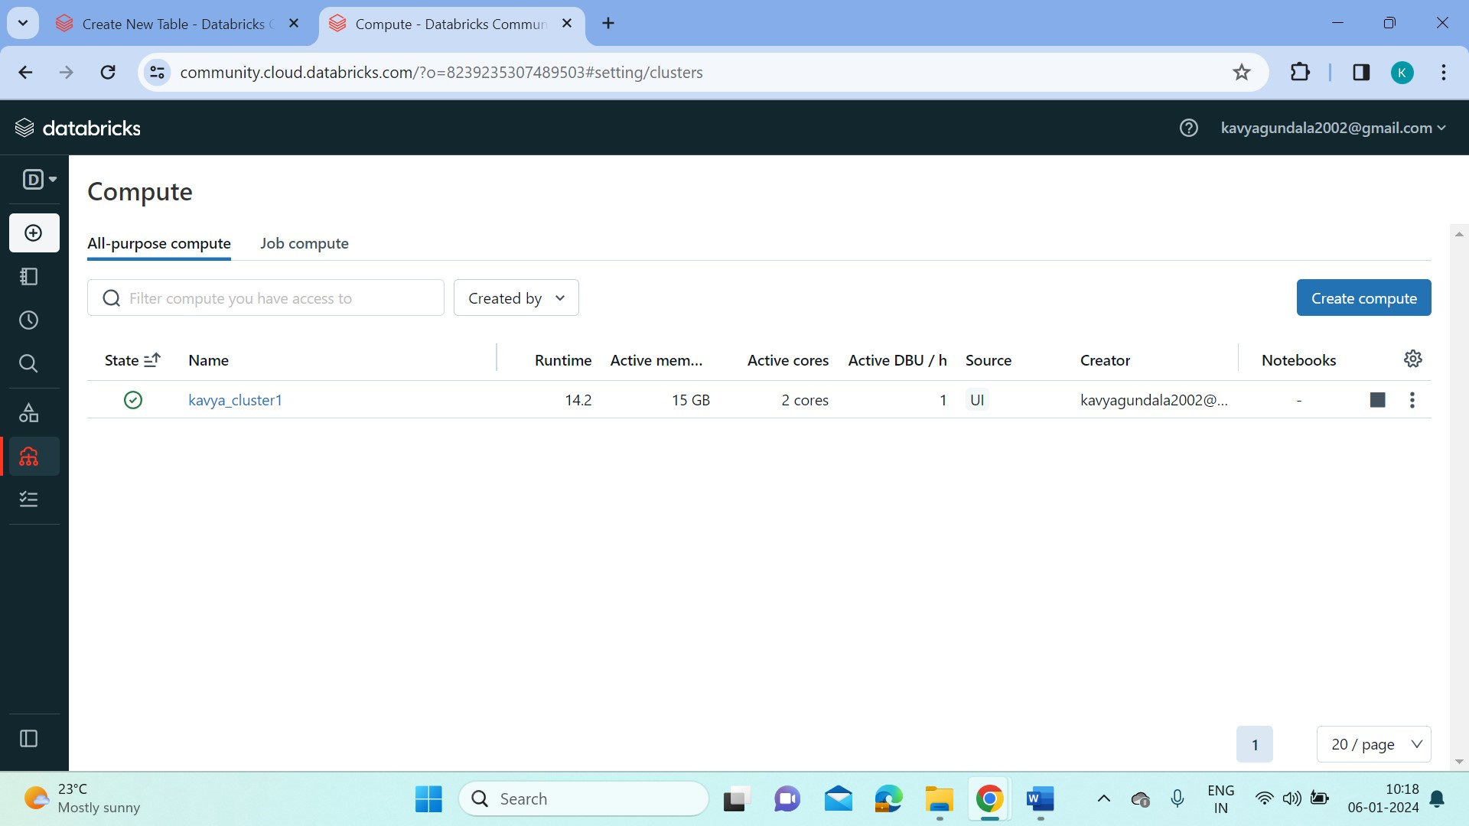

* Open a notebook and rename it as Query Notebook1.
* Connect the notebook to the created cluster to the created cluster.
* Start loading the file into the dataframe.

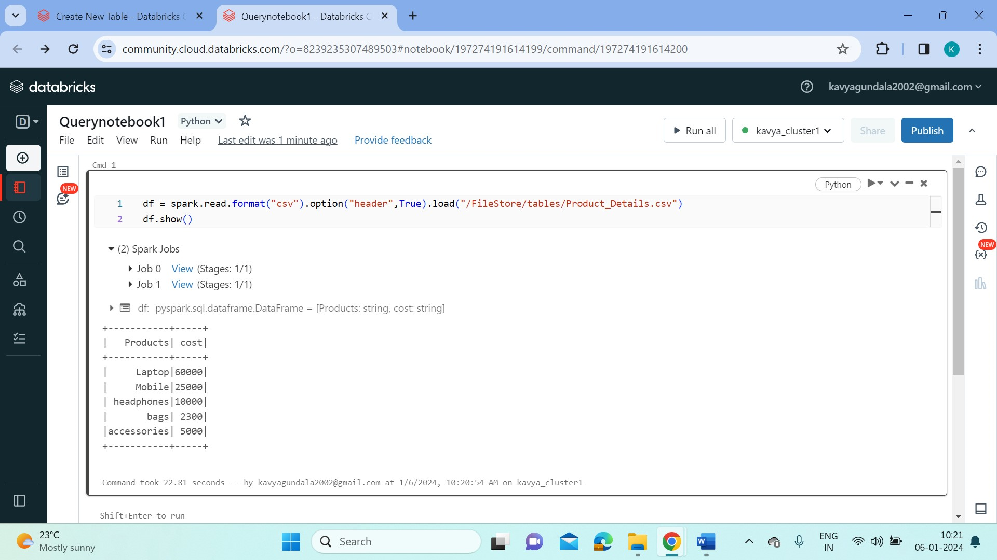

* Now we convert the csv file into delta table using the below command.

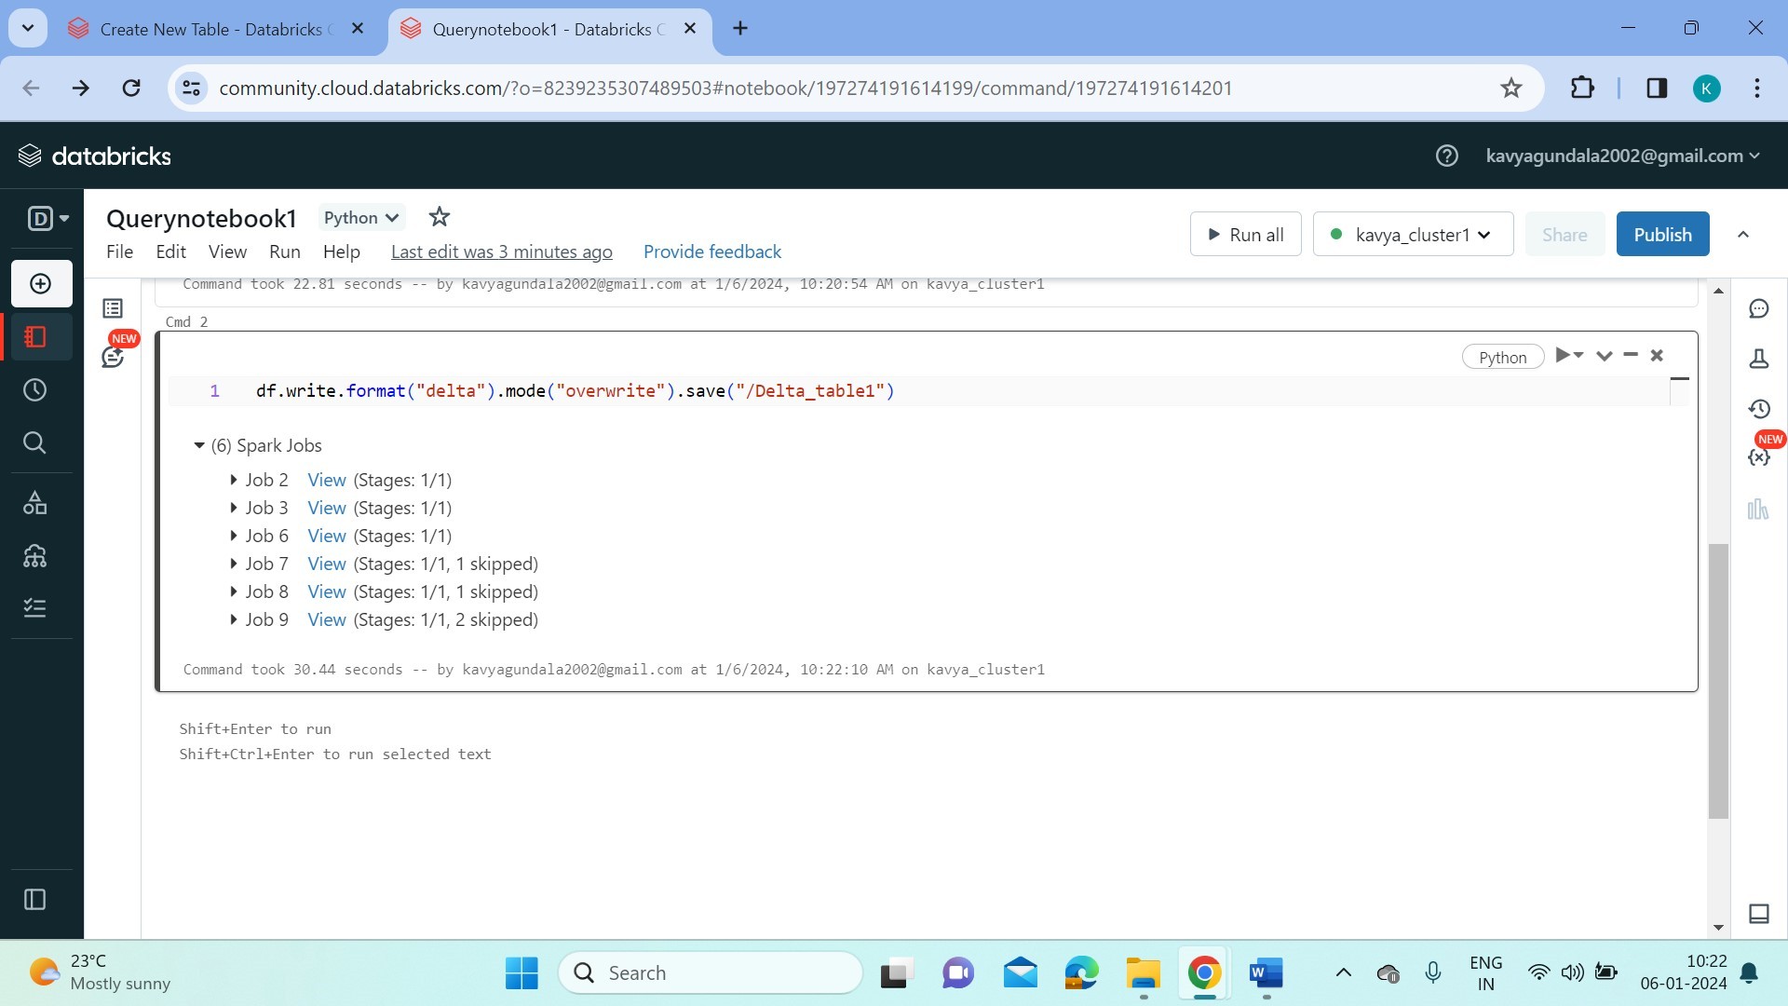

* We can display the data in the delta table using below command,

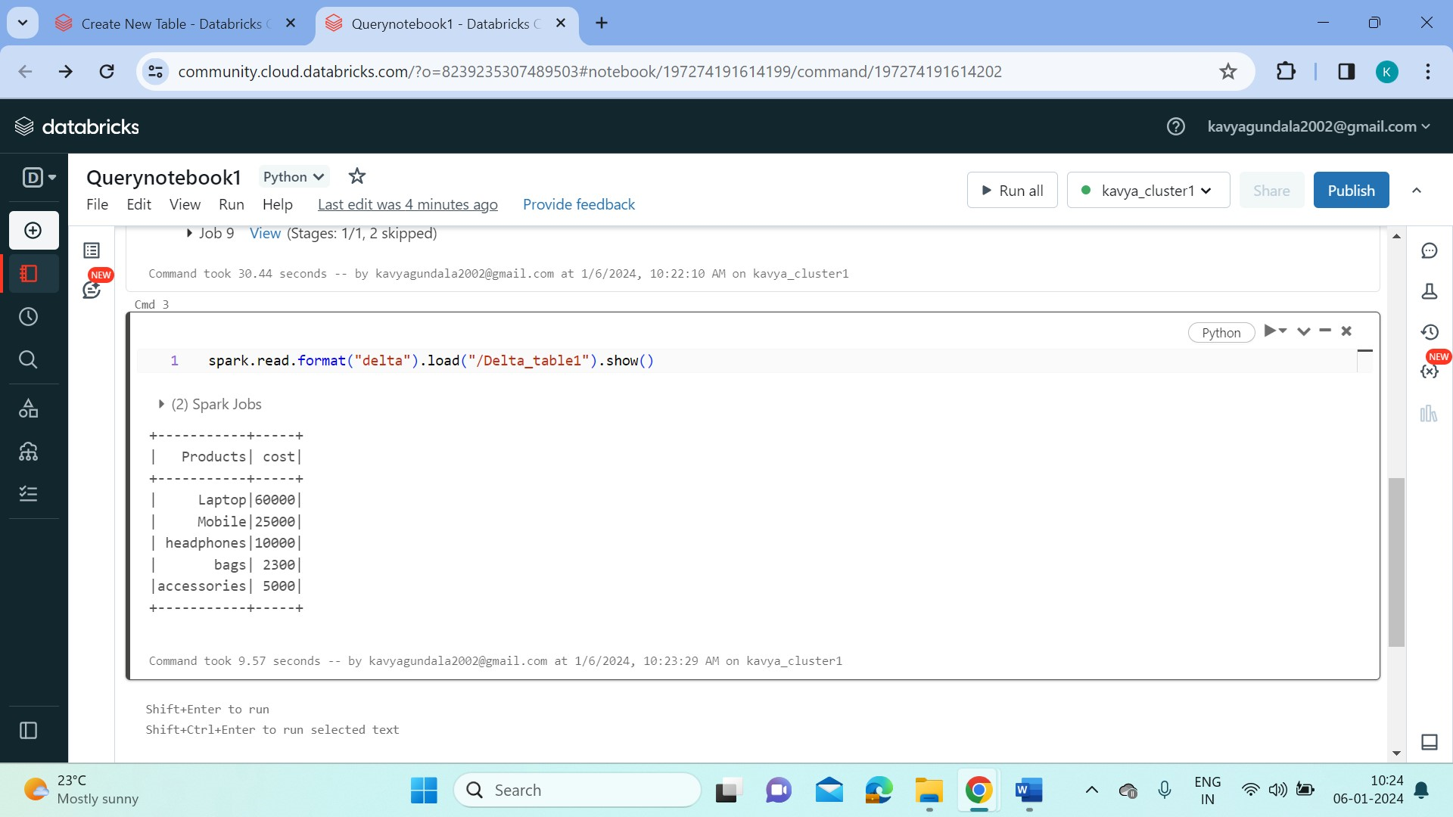

* Execute a sql command in our notebook.

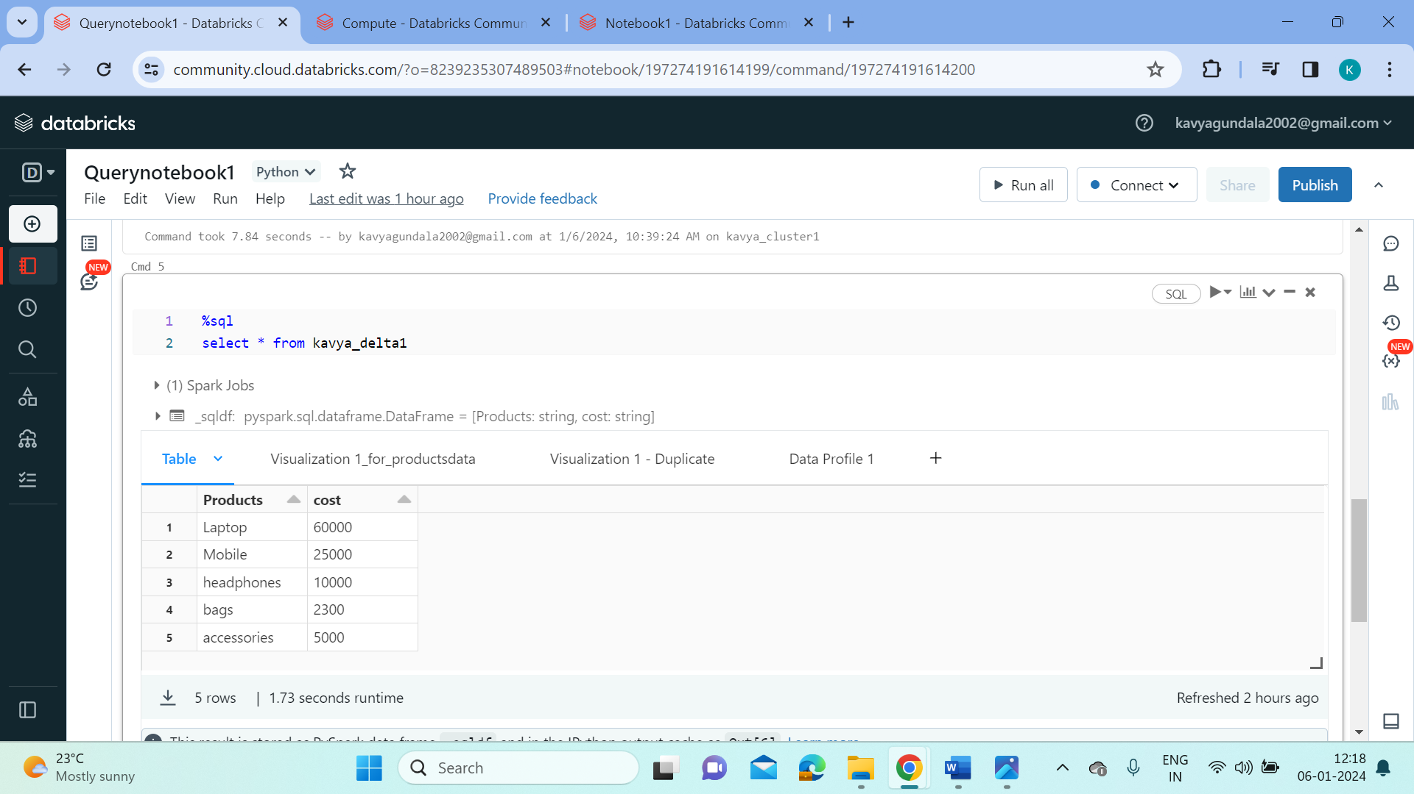

* Now let’s visualize the table in bar chart.

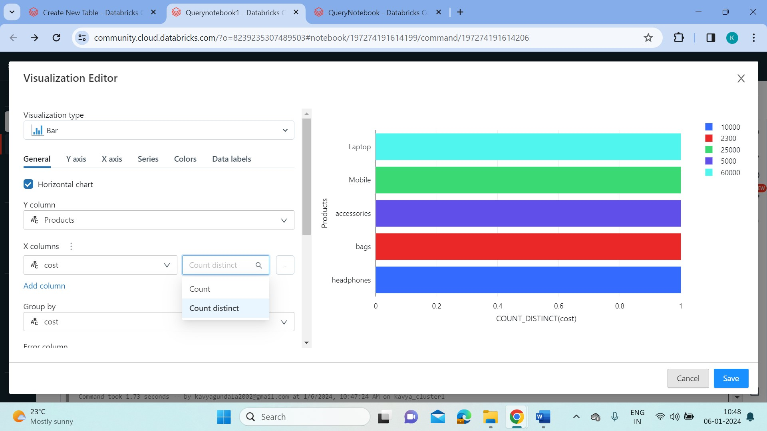

* Click on save so that the visualization appears on the notebook.
* Now we’ll try to rename a visualization in the notebook.

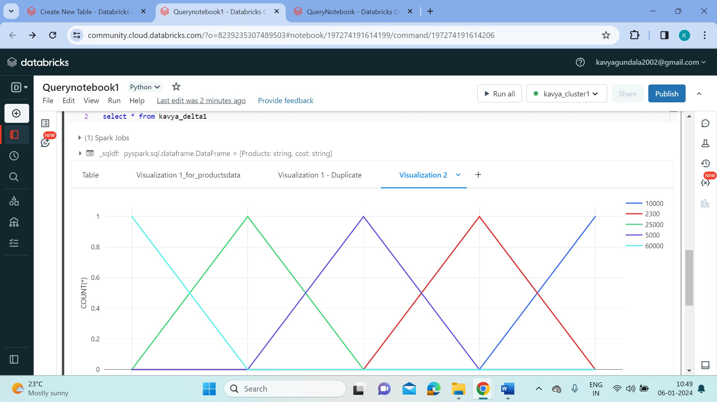

* Click on the dropdown and select rename.

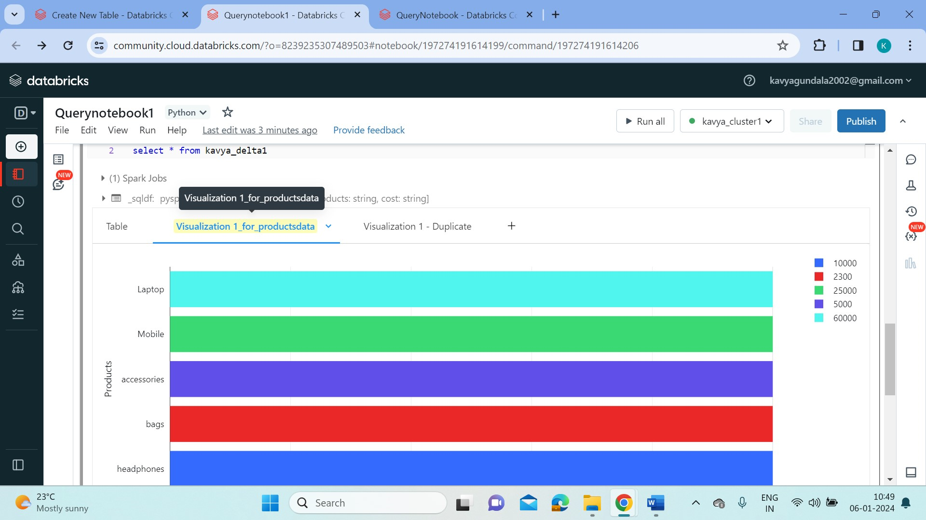

* To create a duplicate visualization click on duplicate.

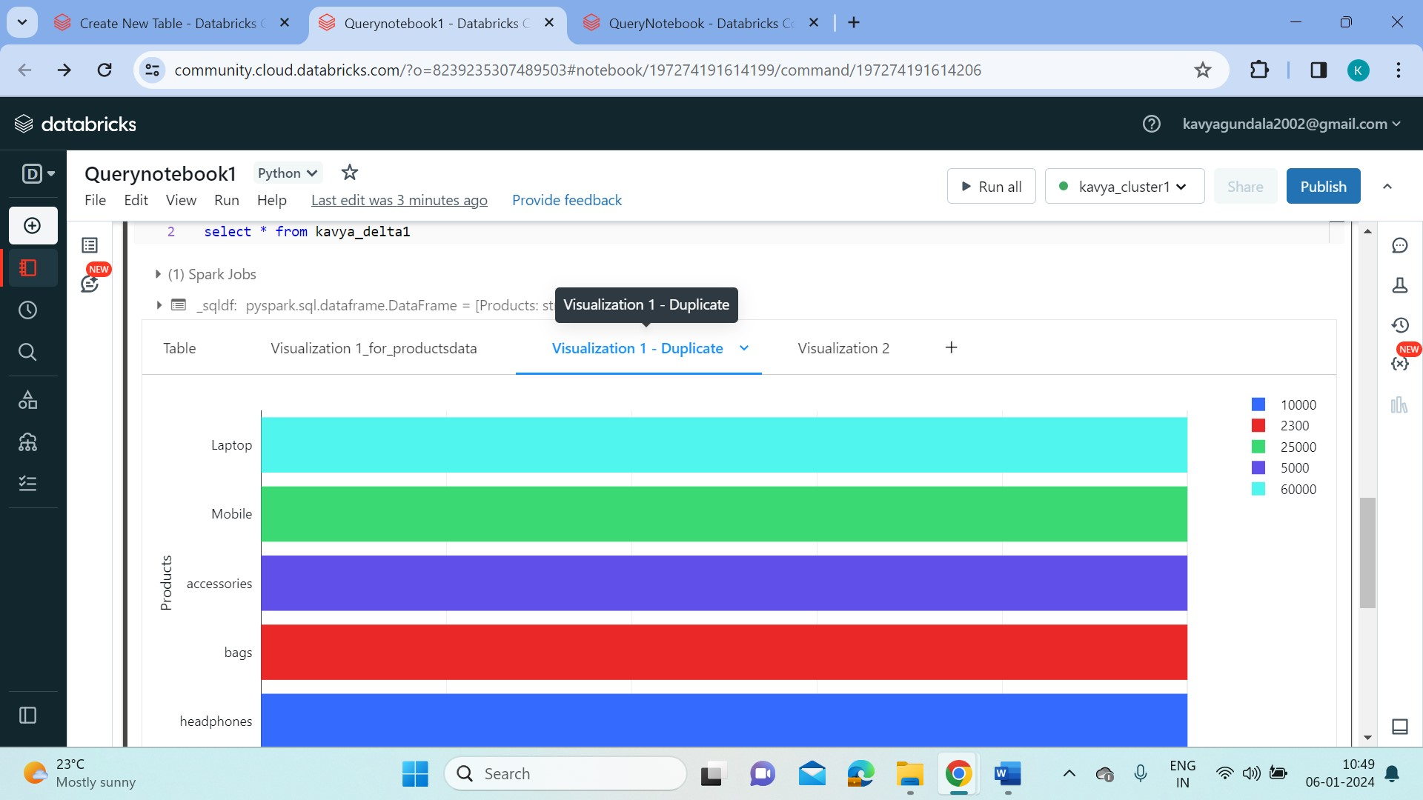

* Now let’s create a line chart for the data.



* To remove a visualization click on remove.

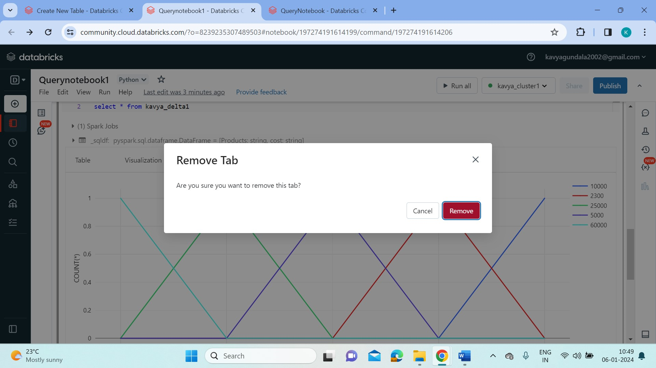

* We can add Data profile to the data in the same way.

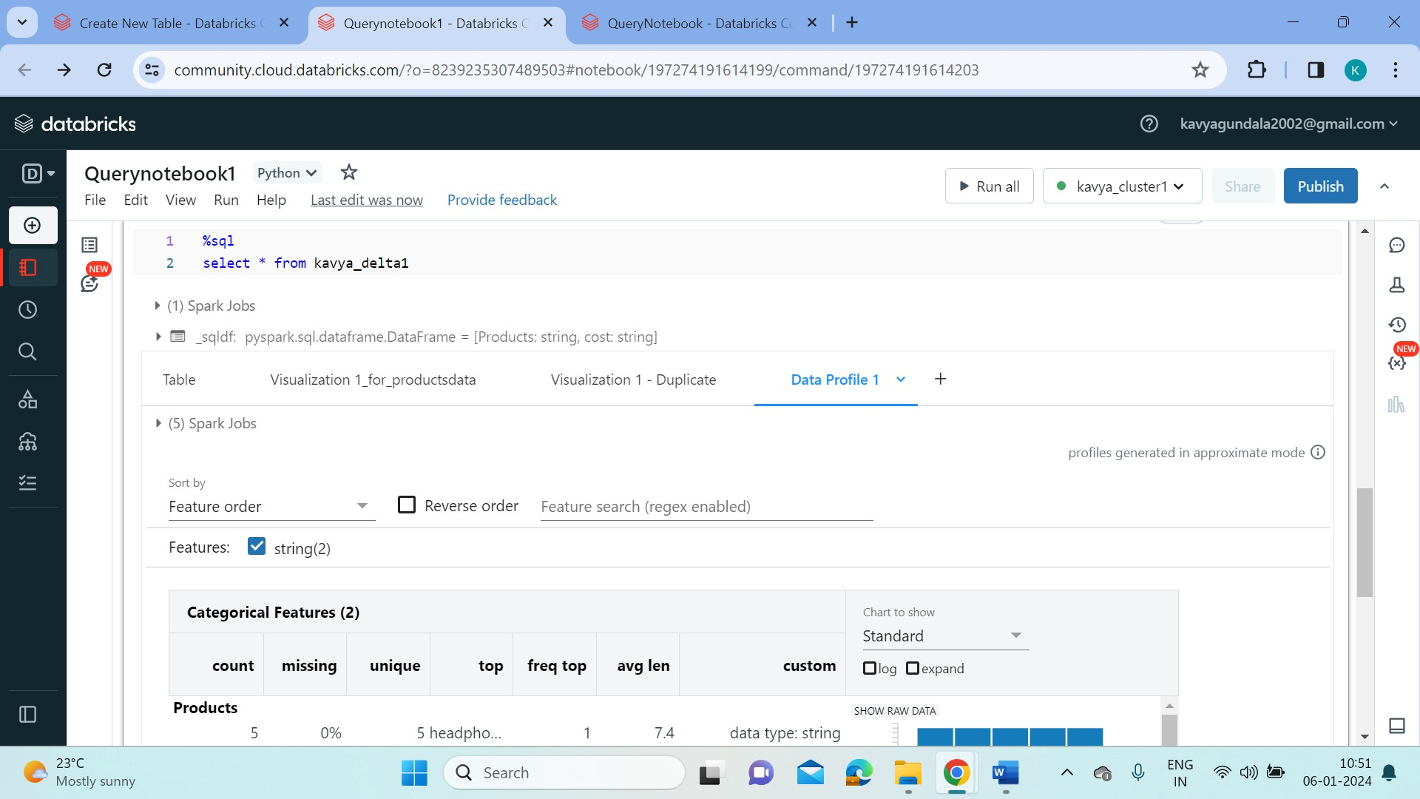

**2.Explain the copy activity in Azure data factory.**

**Azure Data Factory:**

* Azure Data Factory is a cloud-based data integration service that allows you to create data-driven workflows in the cloud for orchestrating and automating data movement and data transformation.
* ADF does not store any data itself. It allows you to create data-driven workflows to orchestrate the movement of data between supported data stores and then process the data using compute services in other regions or in an on-premise environment. It also allows you to monitor and manage workflows using both programmatic and UI mechanisms.
* The Data Factory service allows you to create data pipelines that move and transform data and then run the pipelines on a specified schedule (hourly, daily, weekly, etc.). This means the data that is consumed and produced by workflows is time-sliced data, and we can specify the pipeline mode as scheduled (once a day) or one time.

**Creating Azure Data Factory Pipeline:**

* Here, In ADF Pipeline we create a source and destination storage accounts for data storage.
* So let’s create a source storage account “kavyastorage” and go to containers tab and create a folder ”kavyacontainer1” to upload data files into it.

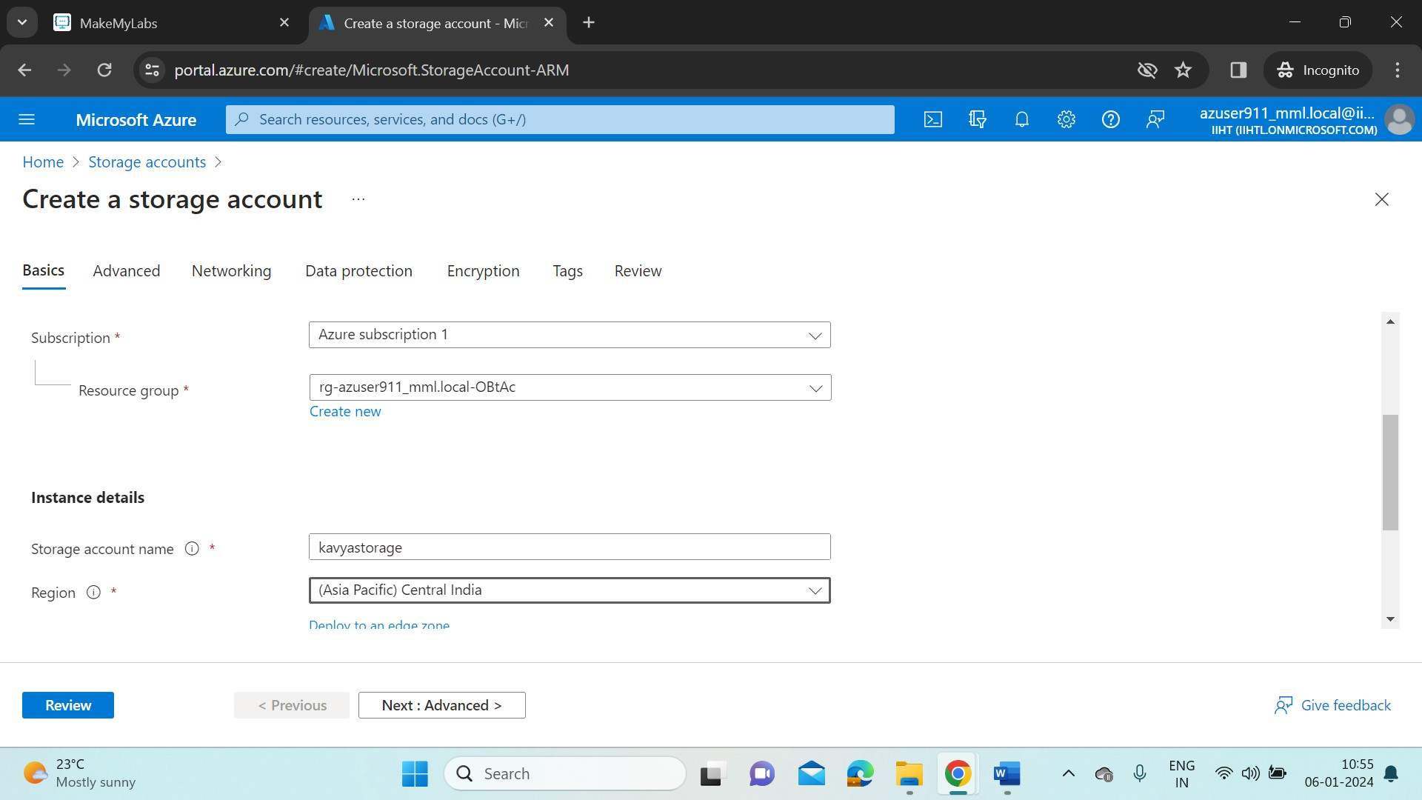

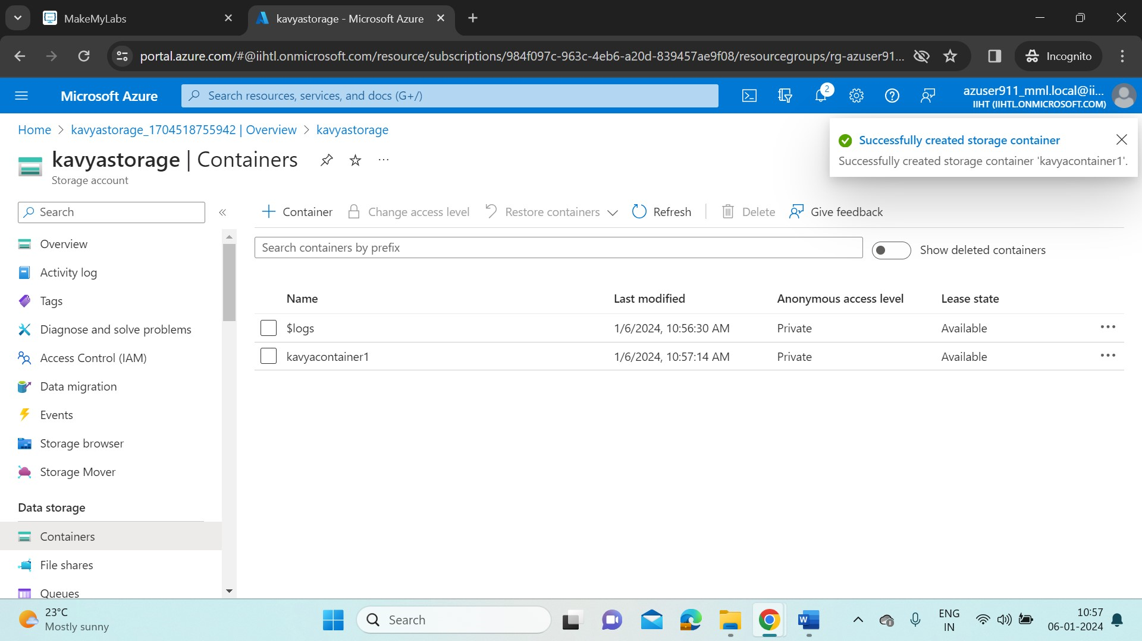

* Here, in this container we upload data files as a blob storage. So a blob storage can handle unstructured data such as .csv, .jpg, .png, .mkv, .gif etc..
* Now in this container I’ve uploaded a Product_details.csv file.

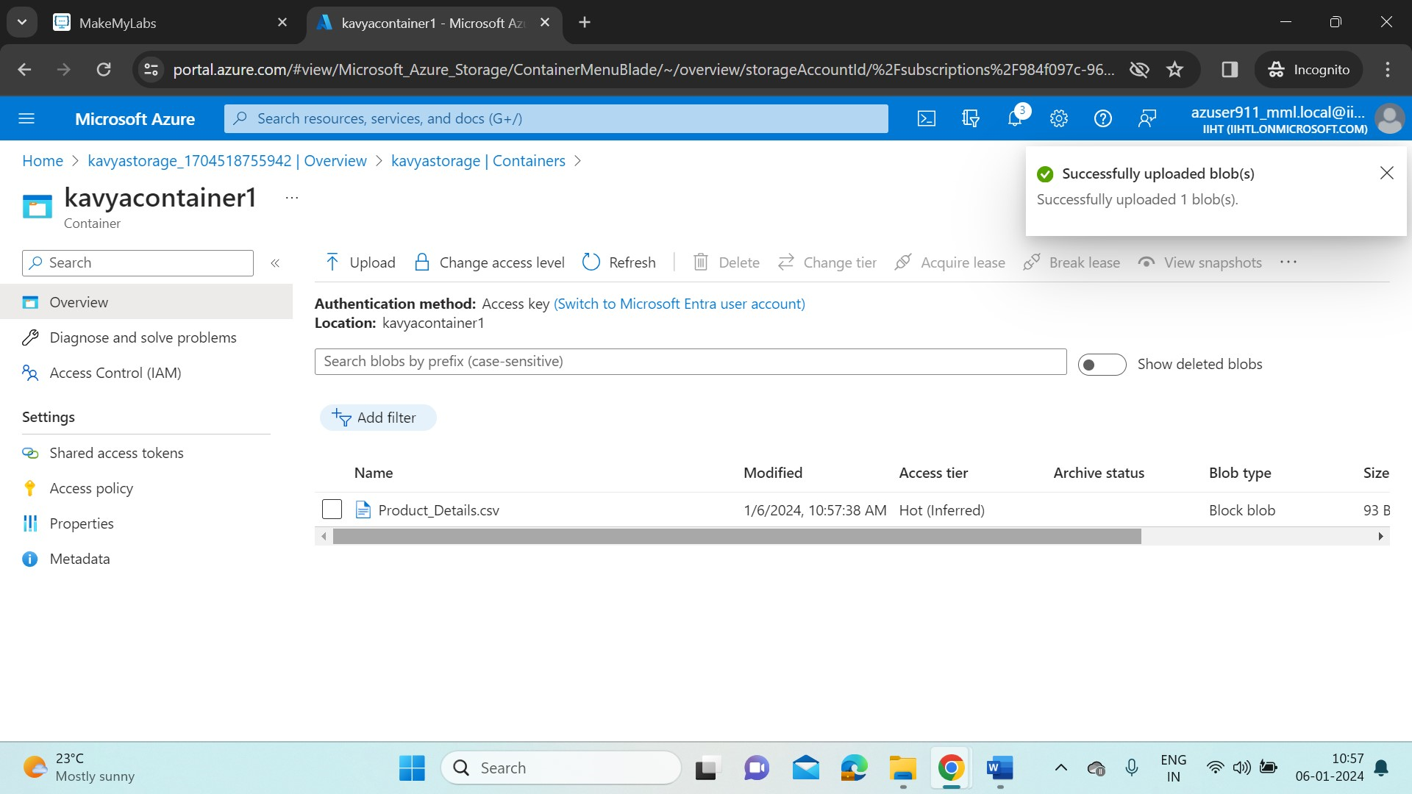

* Now let’s create a data lake storage gen2 storage (built on blob storage with extra features such as low-cost, high-availability, better fault recovery management).
* So create a gen2 storage account “kavyastoragegen2”. ADLS Gen2 will be enabled when in advanced tab “Enable hierarchical namespace” is checked.

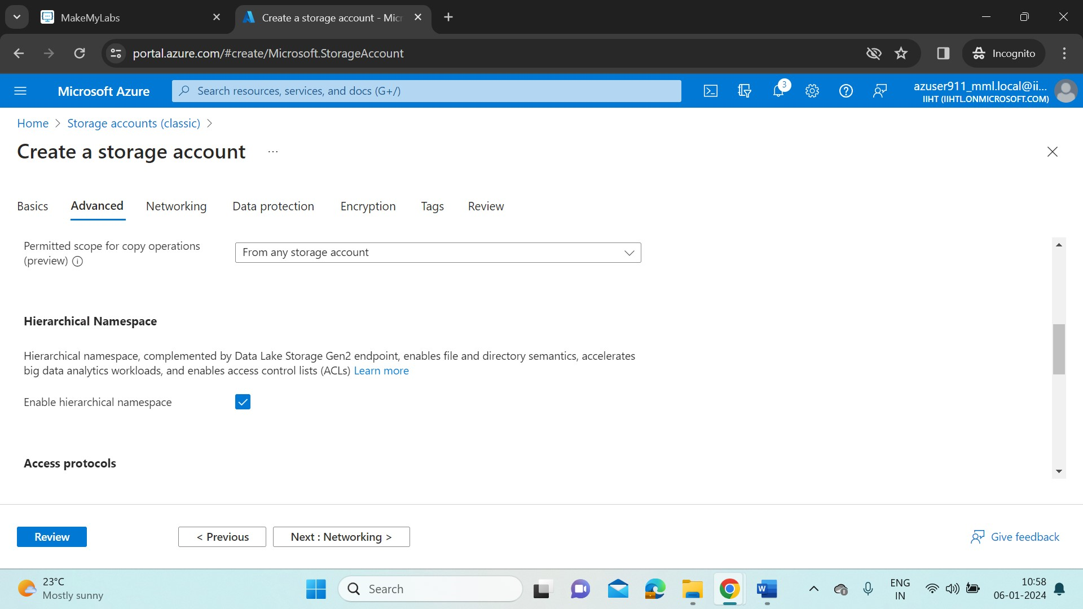

* This is the destination storage account in our pipeline. So to store data in this account, click on containers tab and then create a container “output” with no data.

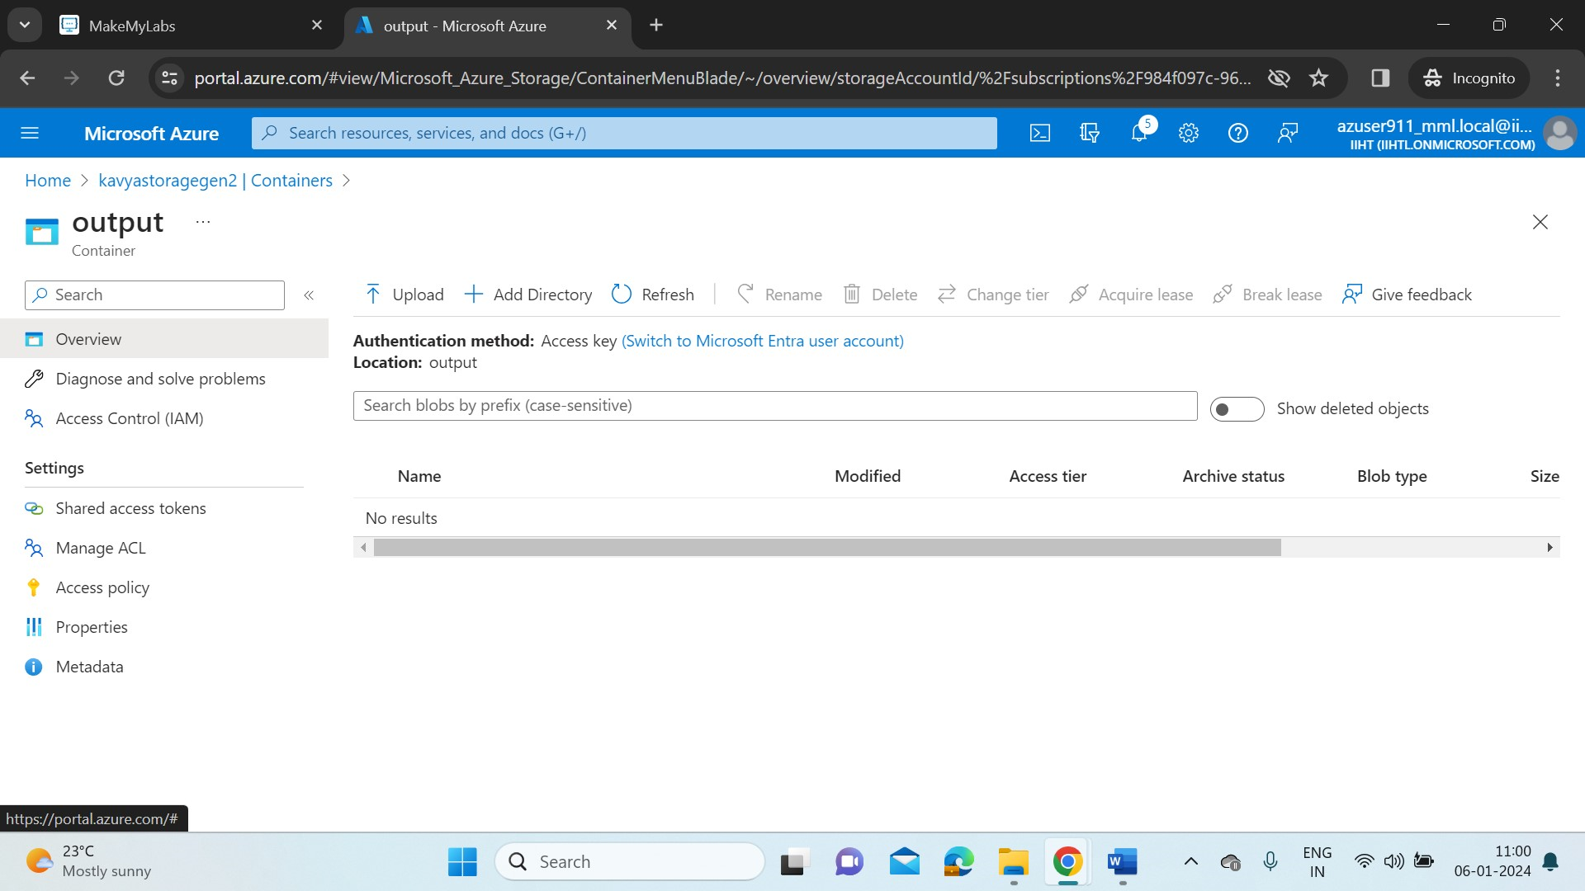

**Create a Data Factory resource:**

* In Azure portal home, search for data factories and create a ADF named “kavyadatafactory1”. After the resource is created, go to resource and click on Launch studio.

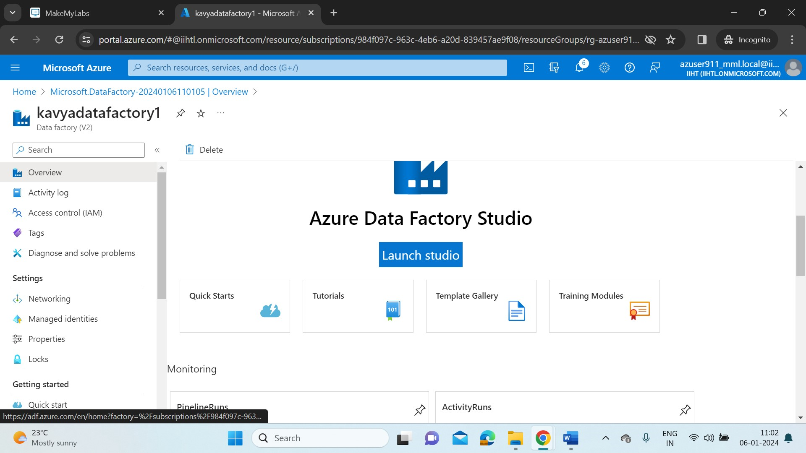

* A new Azure Data Factory portal will opened. Select the Ingest tile to start the copy data tool.

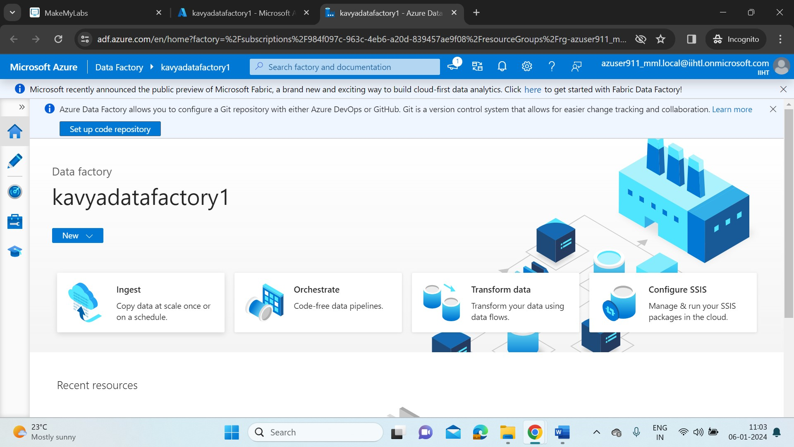

* Select the Built-in copy task and under Task Schedule click Run once now.

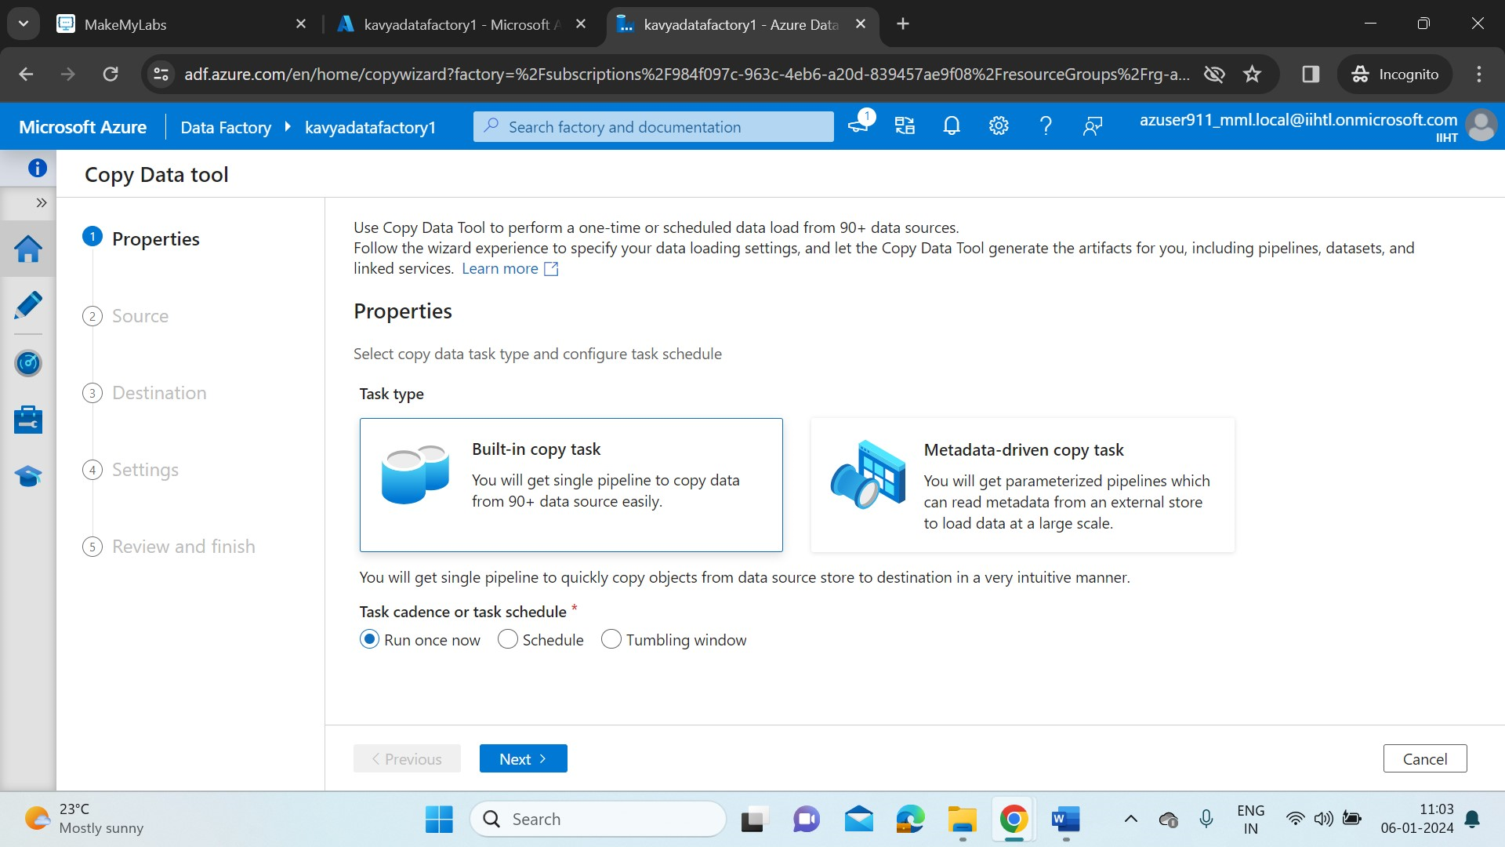

* Now, choose the Source for data ingestion in Pipeline. The type of the storage account created is Azure Blob storage. And for connection, click on new connection and give the name and provide the subscription details with storage account name.
* To check , click on Test Connection. After validation, click on create.

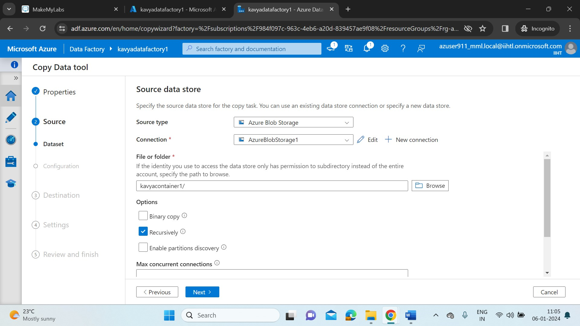

* Provide the path of source folder/file. And enable recursive as we want to run our pipeline whenever we require.
* Now give the destination storage account type(as ADLS Gen2), connection(ADLS Gen1) and provide the destination path to the pipeline.

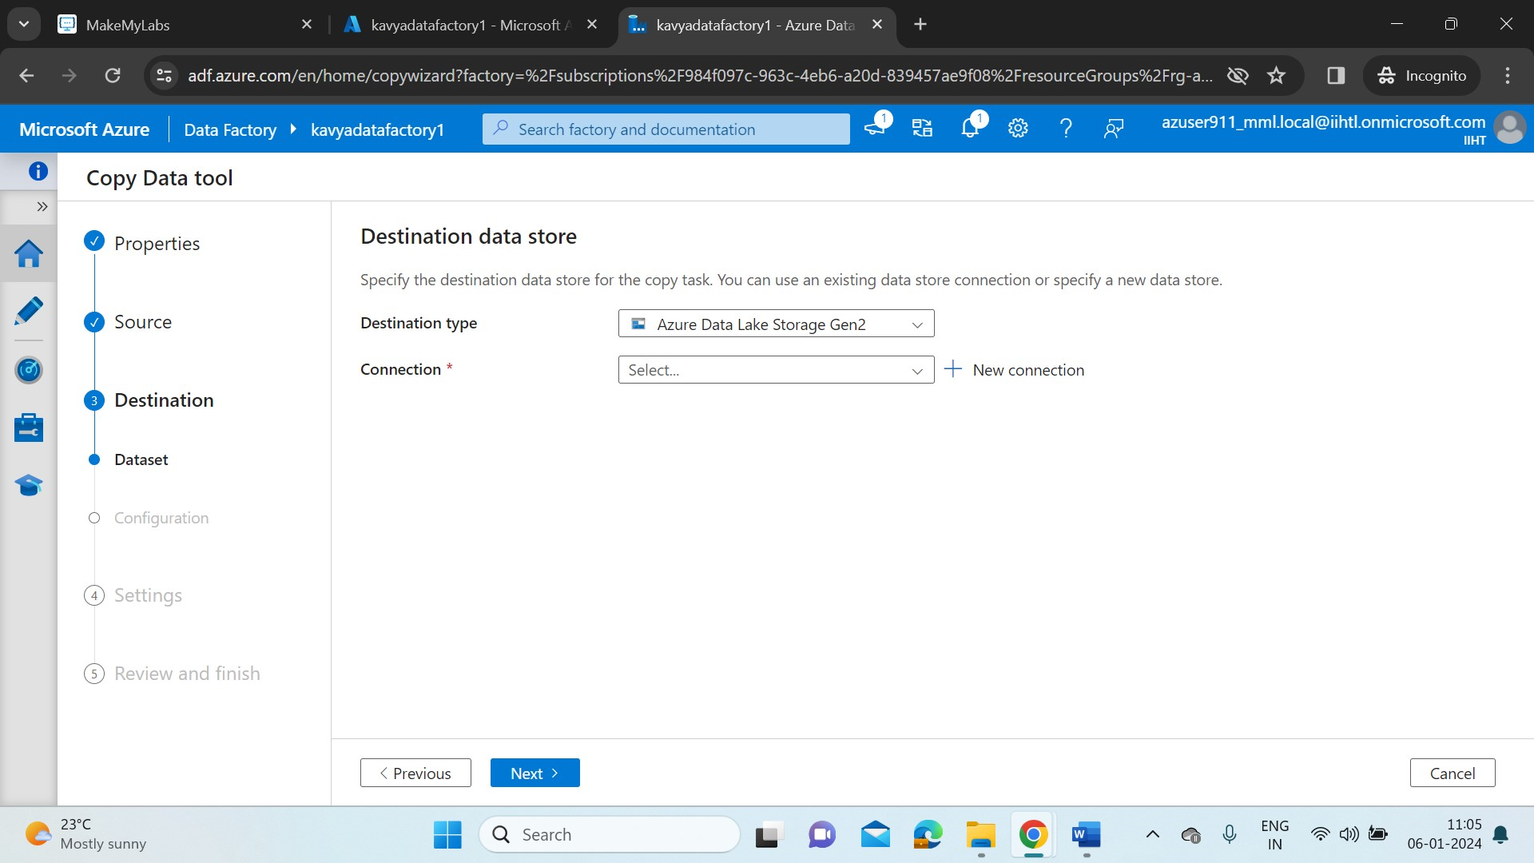

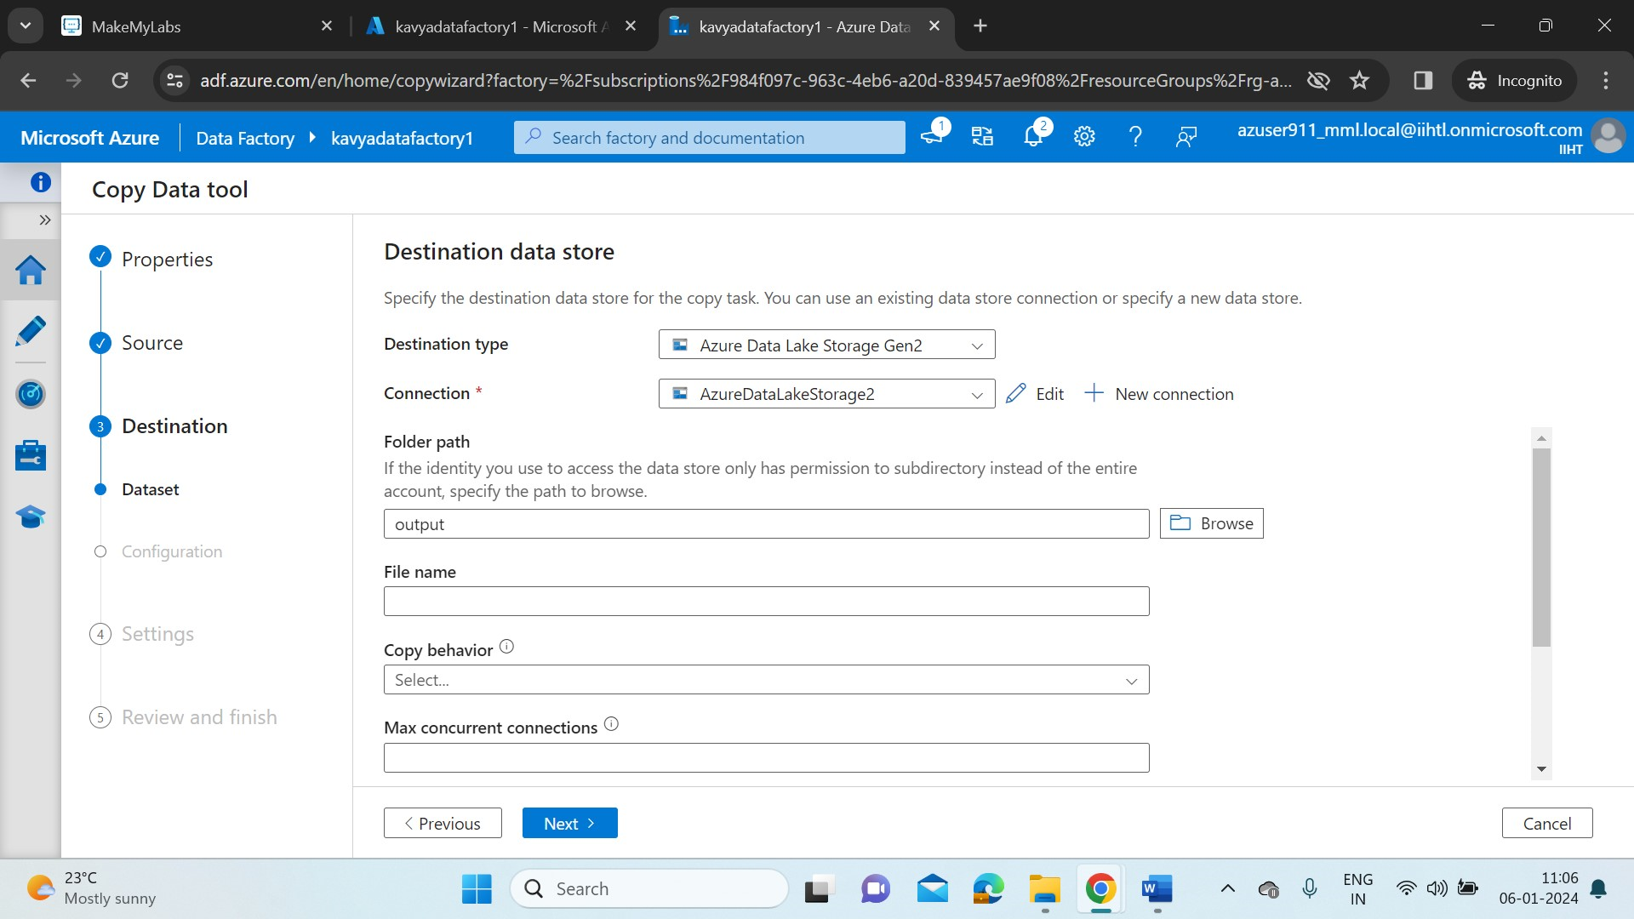

* Now, create a task for pipeline and name it as CopyPipeline_2us.

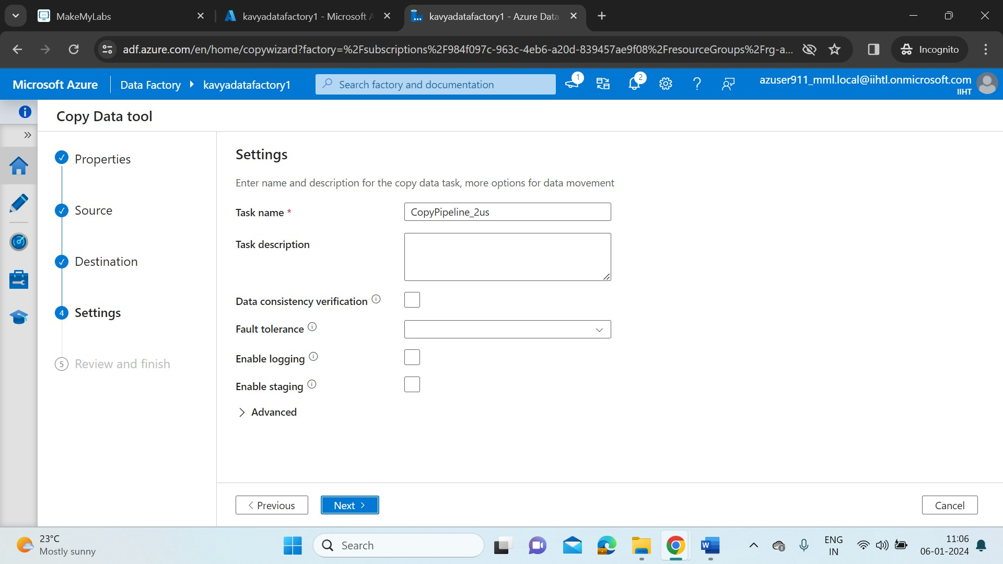

* Click on Next. We can review our pipeline details here. Once it is done, click on Next.

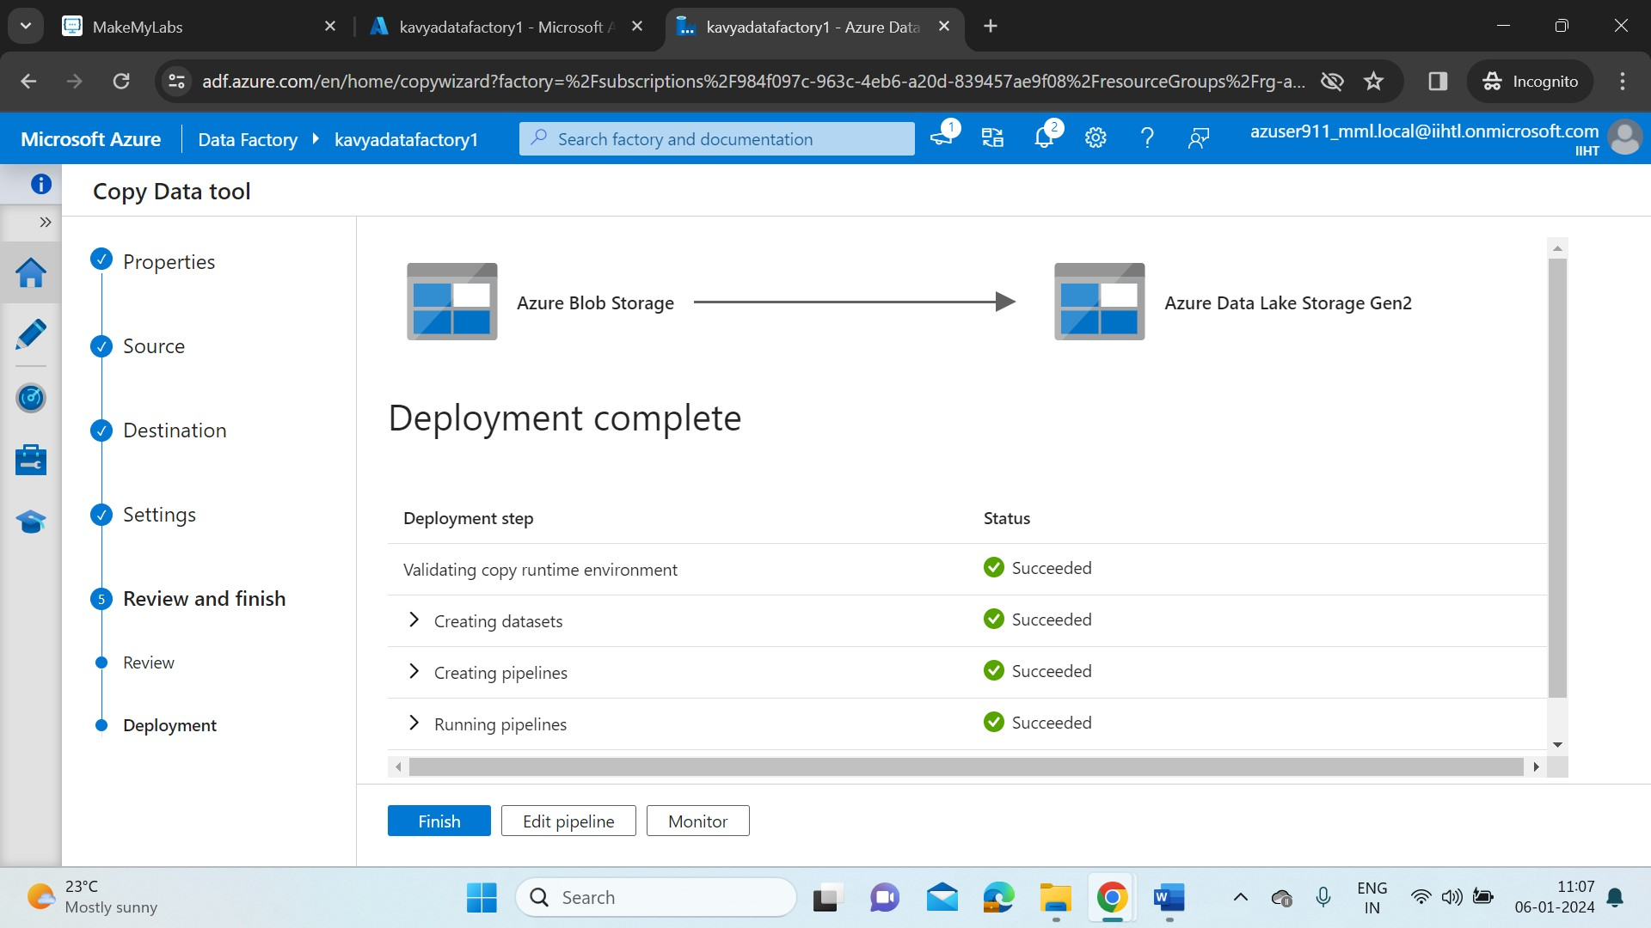

* Here, the tool will show us the status of our deployment task.
* Click on Monitor. In the Monitor tab, it will show us the run details of the task.

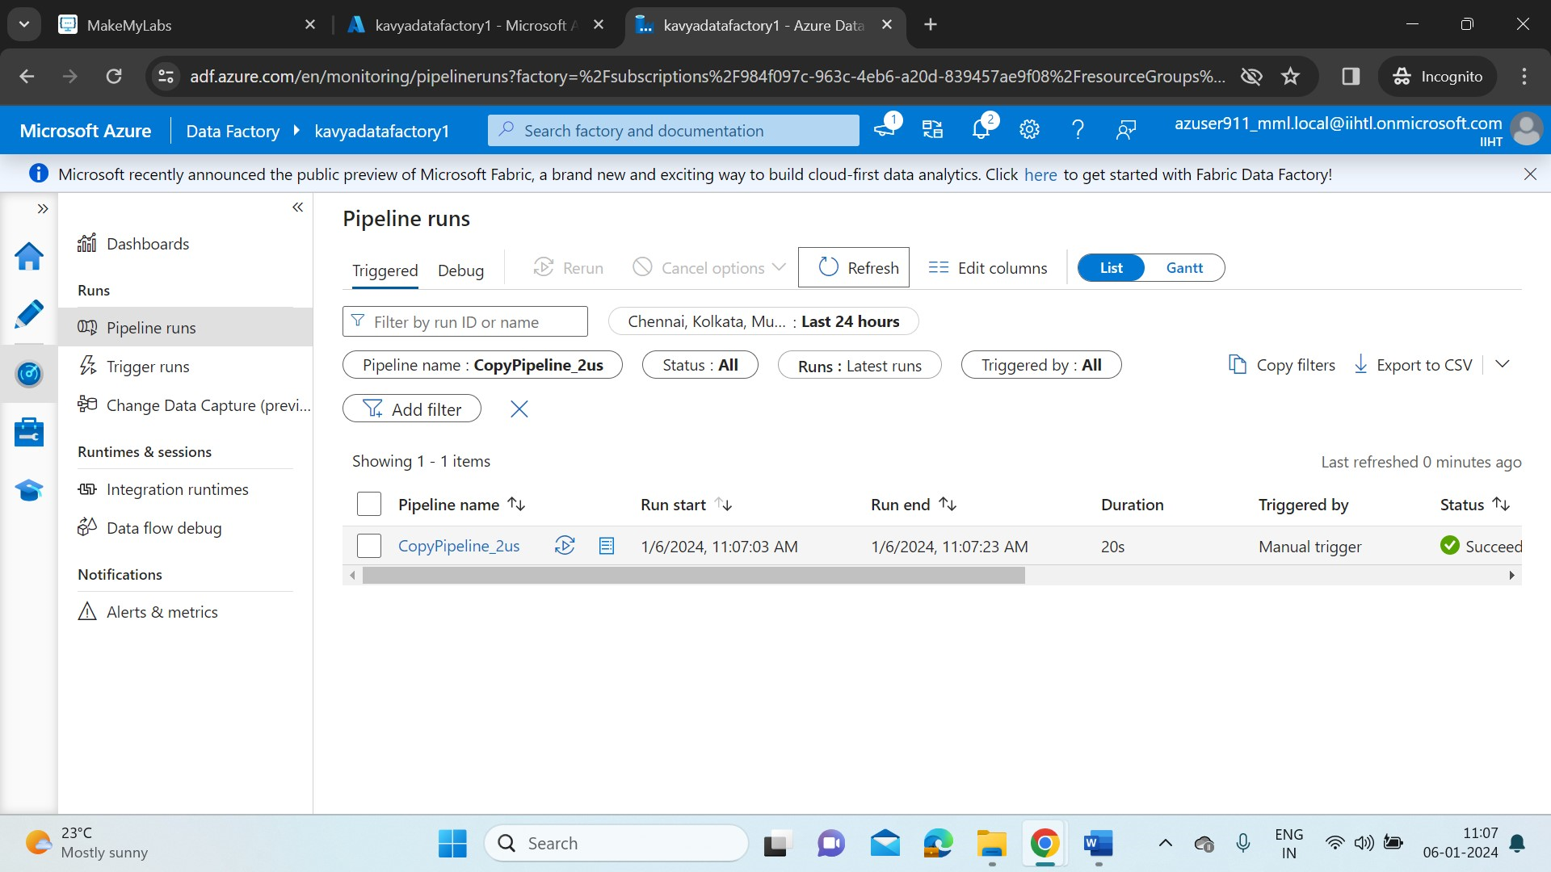

* In the activity tab, we can see our task is success.
* Now check if our destination file is updated with the data we’ve uploaded in source file.

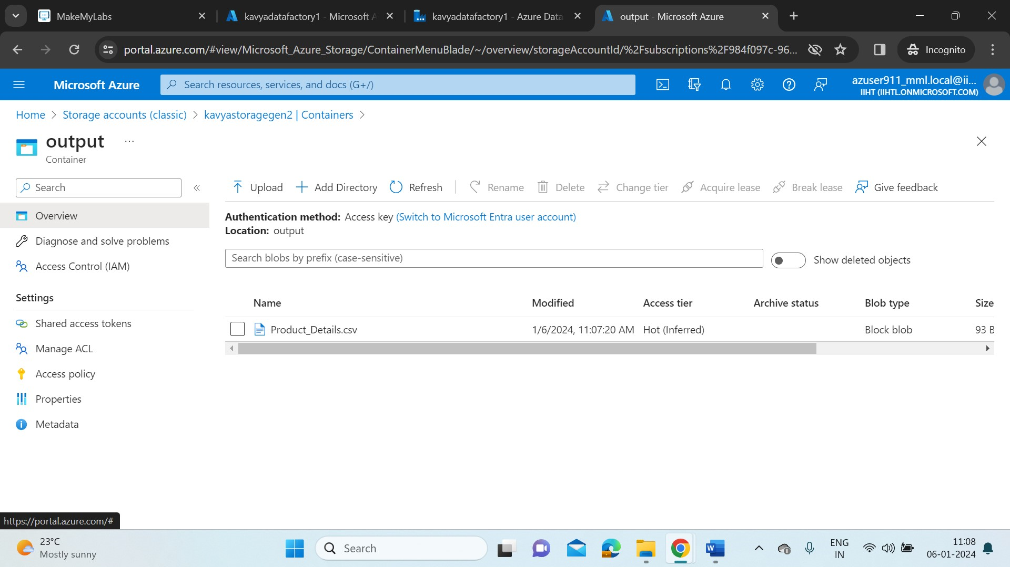

* Product_Details.csv is added to our output container in destination storage account.
* Now we will try adding more files(Added Products1.csv) into our storage account and rerun our pipeline to check if our ingestion is recursive when we add new files.

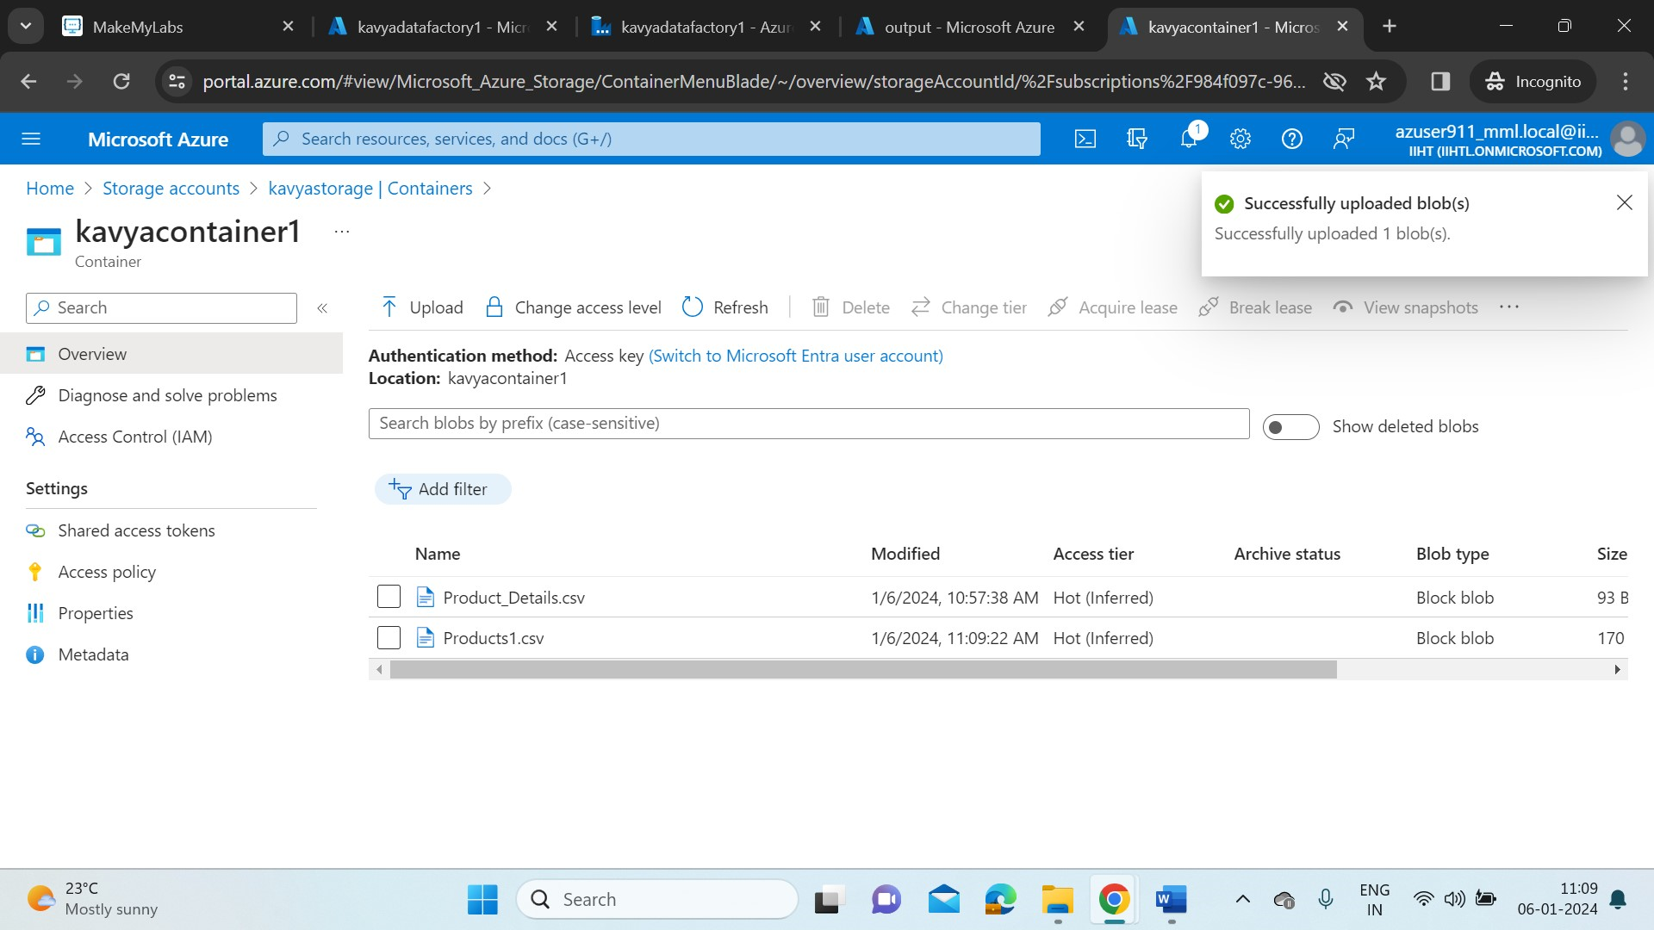

* Click on rerun in the ADF pipeline portal.

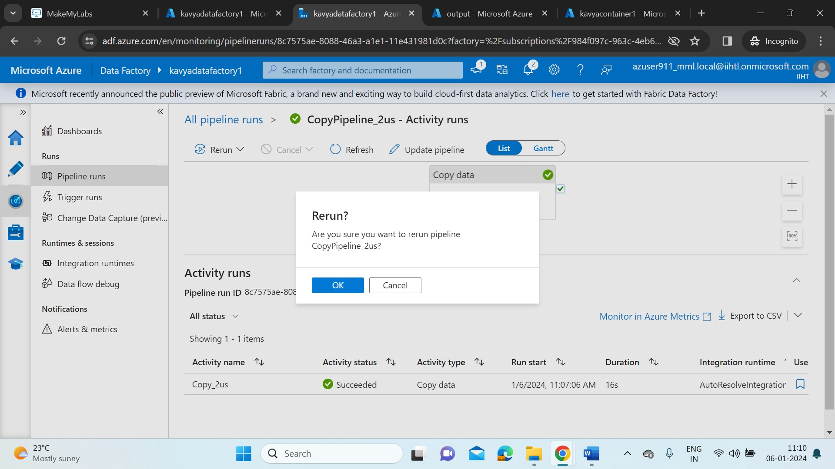

* Once again check in the destination storage account, if the file is added.

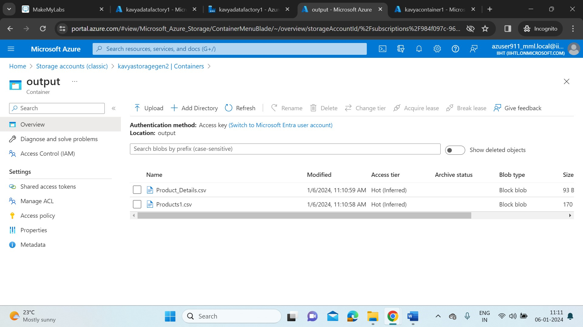

* We can see the file is added here in Output container.
* In this way the ADF allows us to create workflows (pipelines) to move and transform data on a specified schedule.
* The copy activity in ADF is completed. It is best practice to delete the resources no longer in use.